

STARHUB LTD

REQUEST fOR TeNDER

**FOR THE SUPPLY, INSTALLATION, IMPLEMENTATION, AND MAINTENANCE OF MediaHub NextGen DCN**

**Proof Of Concept**

Contents

1 POC infrastructure 3

1.1 POC Setup 3

1.2 Underlay 4

1.3 Compute & Storage 4

1.4 Overlay 4

2 Underlay 5

2.1 Test Matrix 5

2.2 Test Cases 6

3 Compute & storage 8

3.1 Test Matrix 8

3.2 Test Cases 8

4 Overlay 10

Use Case Overview 10

4.1 Test Matrix 11

4.2 Test Cases 14

5 Interoperate Test 16

5.1 Test Matrix 16

5.2 Test Cases 16

6 Security 18

6.1 Test Matrix 18

6.2 Test Cases 19

# 1 POC infrastructure

## 1.1 POC Setup



* We want the Data center equipments to be interconnected within all vendors to form a common Data Center infrastructure as shown in diagram.
* The StarHub Enterprise equipments should also be the same.
* Connectivity between external, Enterprise and DC network should be base on vendor’s proposal.

## 1.2 Underlay

|  |  |  |  |  |  |
| --- | --- | --- | --- | --- | --- |
| **Equipment Model** | **Role** | **Software Version** | **10G**  **Port Count** | **1G**  **Port**  **Count** | **Description** |
|  | Spine Switch |  |  |  |  |
|  | Leaf Switch |  |  |  |  |
|  | DCI |  |  |  |  |

## 1.3 Compute & Storage

|  |  |  |  |  |
| --- | --- | --- | --- | --- |
| **Equipment Model** | **Role** | **Software Version** | **Capacity** | **Description** |
|  | Server |  |  |  |
|  | Hypervisor |  |  |  |
|  | Storage |  |  |  |

## 1.4 Overlay

|  |  |  |  |
| --- | --- | --- | --- |
| **System** | **Role** | **Software Version** | **Description** |
|  | Orchestrator |  |  |
|  | Controller |  |  |
|  | VNF Manager |  |  |
|  | VIM |  |  |

# 2 Underlay

## 

## 2.1 Test Matrix

|  |  |  |
| --- | --- | --- |
| **Test Case ID** | **Test Case Description** | **Expected Result** |
| 1 | High Availability / Redundancy / Resiliency Testing | |
| 1.1 | Demonstrate the hardware redundancy of the equipment such as the following failures   * Line card * Power Supply * Supervisor Module | Demonstrate the hardware redundancy. |
| 1.2 | Demonstrate the traffic failover upon failure of following equipments   * Spine Switch * Leaf Switch | Traffic should be able to redirect to the working path with min or no service impact |
| 2 | Layer 2 and 3 Feature | |
| 2.1 | Demonstrate the layer 3 features base on the proposal submitted. Example IS-IS ECMP 32 | Routing and load balance features should be working |
| 2.2 | Demonstrate the equipment capability for VXLAN, VTEP   * Maximum hardware supported VXLAN number + 1 * Jumbo Frame 9100 | Equipment must be able to perform L2 and L3 VXLAN and VTEP on each interface. |
| 2.3 | Demonstrate the DCI   * Interconnectivity within Data Centers * Interconnectivity between StarHub Enterprise and Data Center network * Connectivity to external network | Connectivity should be up and reachable to the networks. |
| 3 | Hardware Programmability | |
| 3.1 | Ability to auto provisioned the underlay equipments;   * When new servers are connected * Routing to enable service chaining etc. | Auto configuration of the under equipments |
| 3.2 | Ability to redirect traffic flow base on VLAN, source and destination IP addresses, etc  Base on but not limited to the following   * NETCONF / YANG * OpenFlow 1.4 | Redirection of the traffic |

## 2.2 Test Cases

Bidder shall use the sample format to create test cases base on the test matrix accordingly to their propose solution.

Sample Test Case format

|  |  |
| --- | --- |
| **Objective:** |  |
| **Significance:** |  |
| **Test equipment:** |  |
| **Test Parameters:** |  |
| **Test Sequence:** |  |
| **Expected Results:** |  |
| **Test Results:** |  |
| **Remark:** |  |

# 3 Compute & storage

## 3.1 Test Matrix

|  |  |  |
| --- | --- | --- |
| **Test Case ID** | **Test Case Description** | **Expected Result** |
| **1** | **BareMetal / Operating System / Storage Provisioning** | |
|  | * VMware / RedHat KVM * Management IP Provisioning * Host IP Provisioning * OS Provisioning * Storage Provisioning * Rate of Provisioning | Automated Provisioning |
| **2** | **High Availability / Redundancy / Resiliency Testing** | |
|  | * Host failure / VM failure * SAN Switch failure / SAN Link | [Automated]  VM / Link provisioning / OS file system checks.  Both Fortinet vFW and Brocade vRouter comes with HA solution  Check with Nera on DHCP/DNS/ Fault management/configuration management |
| **3** | **SAN Traffic Flow and CRC error checks** | |
|  | * > 4 hops * Over-subscripted > 80% * Latency Test | [Automated]  Interoperable Demonstration  Check with StarHub what is the performance expectation |
| **4** | **IOPS and Bandwidth Throughput Test** | |
|  | * 4k, 8k, 16k read * 4k, 8k, 16k write | Performance Test  Check with StarHub what is the performance expectation |

## 3.2 Test Cases

Bidder shall use the sample format to create test cases base on the test matrix accordingly to their propose solution.

Sample Test Case format

|  |  |
| --- | --- |
| **Objective:** |  |
| **Significance:** |  |
| **Test equipment:** |  |
| **Test Parameters:** |  |
| **Test Sequence:** |  |
| **Expected Results:** |  |
| **Test Results:** |  |
| **Remark:** |  |

# 4 Overlay

## Use Case Overview

The diagram below describe the use-case

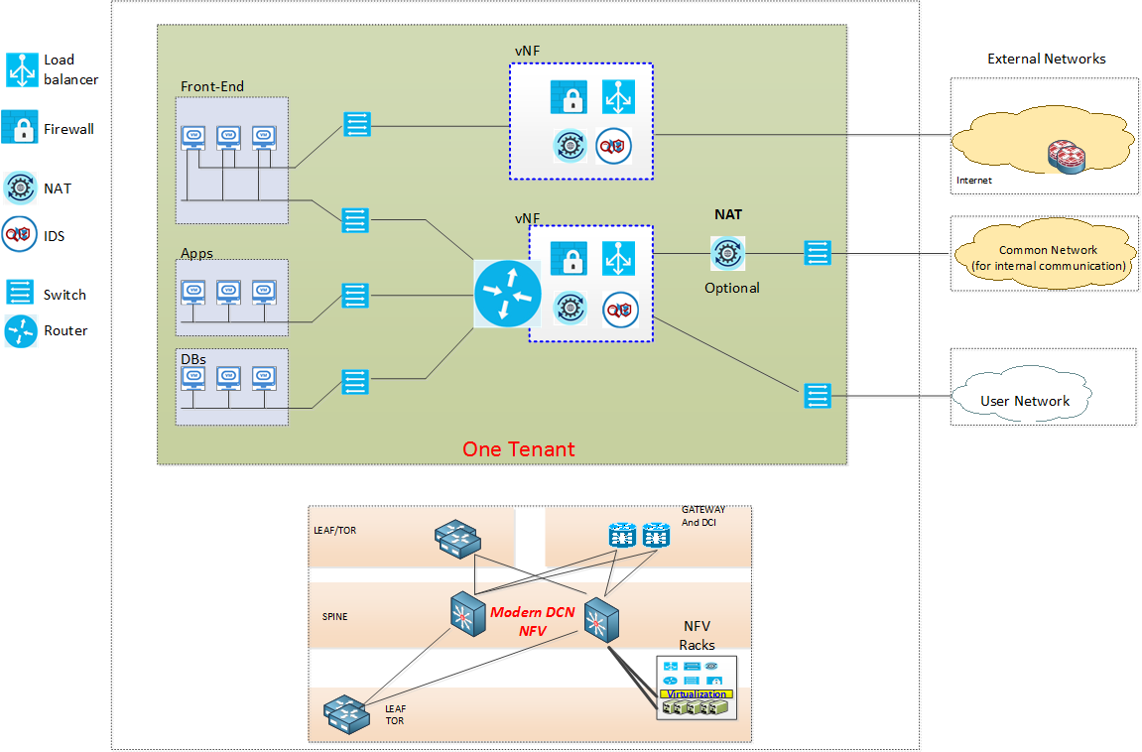

One tenant will have a predefined topology with switches and routers connected in above topology

* Each network segment is a Layer 2 Virtual network
* Communication amongst layer 2 virtual networks are facilitated by Layer 3 Routing
* The tenant can be managed by a user, a group of users with RBAC (Role Based Access Control)
* User who manages the tenant can add/remove additional network functions such as Network segments, Firewall, Load-Balancer, NAT, VPN Concentrator, etc. to suit their needs. The number of network functions and their specifications are controlled when the tenant is created.
* User who manages the tenant can view and edit the network functions assigned to the tenant based on his/her roles
* All user’s activities will be done via a Portal

Below diagram shows an example of inter-tenant communication

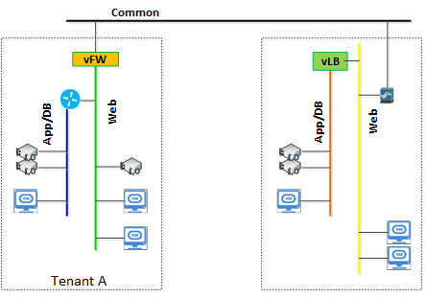

## 4.1 Test Matrix

|  |  |  |
| --- | --- | --- |
| **Test Case ID** | **Test Case Description** | **Expected Result** |
| 1 | Tenant Management | |
| 1.1 | Create tenant with its associated attributes such as: number of network functions, number of license, network functions’ specification.   * Create Tenant A * Create Tenant B * Create Tenant C * Create Tenant D | Successful creation of new tenants with allocated network resources.  Cloudify does not come with tenant management function  In the POC, we may creating multiple Cloudify managers. Each will be mapped to a tenant which are created within VIO/vCD with resource reservation  Cloudify will support multi-tenant in next release  Requirement – Tenant setup in VDC and VIO, details should be known to Cloudify |
| 1.2 | Modify tenant with its associated attributes such as: number of network functions, number of license, network functions’ specification.   * Tenant A – Increase resource * Tenant B – Decrease resource | Successful modify of tenant with allocated network resources.  Cloudify does not come with tenant management function  In the POC, tenant resource modification will be done through VIO and vCD. VMware will demo Cirrus-vCD integration for tenant management |
| 1.3 | Delete tenant with its associated attributes such as: number of network functions, number of license, network functions’ specification.   * Delete Tenant D | Successful deletion of tenant and allocated network resources released. |
| 1.4 | Roles Management  Example: View only, View and Change Configuration, Add/Remove functions, Shutdown/Startup a Function, bind a port (virtual or physical) to a network segment or function.   * Create Role – View Only * Create Role – View and Change configuration * Create Role – Full Rights | Successful creation/modify/deletion of roles  Cloudify can do static (XML file based) role management per manager. Dynamic role management (either XML or UL) will be available in next release) |
| 1.5 | Create user or group of users with role base access   * Create User 1 – Role view only * Create User 2 – Role View and change configuration * Create User 3 – Role Full Rights * Create User 4 – Role Full Rights | Successful creation of user account.  Cloudify does not come with user management function  In the POC, user management will be done through VIO and vCD. VMware will demo Cirrus-vCD integration for user-management  Requirement – integration with VIO/VCD for user credentials for a login through Cloudify. Are we not using LDAP at all? |
| 1.6 | Modify user’s account role   * Modify User 1 role to Full Rights * Modify User 2 role to view only * Modify User 3 role to view and change configuration | Successful modify of user account. |
| 1.7 | Delete user account   * Delete User 4 | Successful deletion of user account. |
| 1.8 | Assign a user or a group of users to tenants   * User 1 – Tenant A,B & C * User 2 – Tenant A,B & C * User 3 – Tenant C | Successful assign user account to tenant |
| 1.9 | Remove a user or a group of users from a tenants   * User 2 – Remove from Tenant C | Successful removal of user account from a tenant |
| 2 | Service Template | |
| 2.1 | Create Network Service Template consisting of Network Functions   * Create Network Service A – 1 x Server, 1 x FW * Create Network Service B – 2 x Servers, 2 x FW * Create Network Service C – 2 x Servers, 2 x FW, 1 x LB * Create Network Service D - 1 x Server, 1 x FW | Successful creation of service template  Cloudify need input from brocade/Fortinet for the virtual appliance profiling so that Cloudify can re-model them based on TOSCA model  Nera has put brocade vSLB as an option part of the submission  Requirement – software, licenses, configuration data (CLI syntax + parameters). For both FW, LB, and vRoute. Ideally also provide a way to test the software (i.e. traffic generator) |
| 2.2 | Modify Network Service Template to add or remove Network Functions   * Modify Network Service A – Add 1 x Server, 1 x FW * Modify Network Service B – Remove 1 x FW * Modify Network Service D – Add 1 x LB | Successful modify of service template  Modifying service template will be supported in the next release  Alternatively, customer may consider adding a new service template and deleting the old service template |
| 2.3 | Delete Network Service Template to add or remove Network Functions   * Delete Network Service D | Successful deletion of service template |
| 2.4 | Assignment of service to 1 or more tenants   * Assign Network Service A – Tenant A,B &C * Assign Network Service B – Tenant A&B * Assign Network Service C – Tenant C | Successful assignment of Network Service to Tenants  In the POC, every tenant will be configured with a Cloudify manager, so network service can be added to the relevant Cloudify manager  The multi-tenant capable service portal will be available in next Cloudify release |
| 3 | IP Management | |
| 3.1 | Creation of NFV Management IP ranges and allocation to tenant   * Tenant A – 172.1.1.0/24 * Tenant B – 172.2.2.0/24 * Tenant C – 172.3.0.0/16, 172.4.0.0/16 | Successful creation of Management IP range for NFVs  Nera will update Starhub what will be DHCP solution  What will be DHCP setup for the POC  Vmware to provide the detailed requirement to Nera on the DHCP setup |
| 3.2 | Creation of NFV IP ranges and allocation to tenant   * Tenant A – 10.1.1.0/24 * Tenant B – 10.2.2.0/24 * Tenant C – 10.3.3.0/24 | Successful creation of IP range for NFVs usage. |
| 3.3 | Modify/addition of each type of IP ranges for tenant   * Tenant C – Modify 172.3.0.0/16 to 172.3.3.0/24 * Tenant C – Add 10.1.1.0/24 | Successful Modify/addition of IP range for tenants |
| 3.4 | Deletion of IP ranges for tenant   * Tenant C – Remove 172.4.0.0/16 | Successful deletion of IP range for tenants |
| 4 | Service Orchestration | |
| 4.1 | Service Creation for Tenants.   * Tenant A – Network Service A   ( Chain Server 1 – FW 1 – External Network )  ( Chain Server 2 – FW 2 – External Network )   * Tenant B – Network Service B   ( Chain Server 1 – FW 1 – Server 2 )   * Tenant C – Network Service C   ( Chain Server 1 – FW 1 – LB1 – External Network)  ( Chain Server 2 – FW 2 – LB1 – External Network) | Success spawning of the VNFs base on service template.  Success allocation of the IP addresses for VNFs.  Service Chaining will be instantiated.  Requirements – Brocade controller information and installation, an installed and configured NSX to be communicated with through VIO/VCD |
| 4.2 | Modify the VNF configuration using the management IP Assigned   * Tenant A – Access the FW1 & 2 to add rules * Tenant C – Access FW 1 & FW 2 to add rules   Access LB1 | User able to access the VNFs and perform configuration changes on them.  Fortinet vFW supports both Web and CLI access for tenant users  Requirement – information re accessing the web server, if we want to enable a direct link to it from the Cloudify portal |
| 4.3 | Service modification for Tenants   * Tenant A – Add LB   ( Chain Server 1 – FW 1 – **LB1** - External Network )   * Tenant B – Add FW 2   ( Chain Server 1 – FW 1 )  ( Chain Server 2 – **FW2** ) | User able to add new VNFs or modify the service chaining.  The feature of modifying the deployed service will be available in next release  For now, we can delete the old provision and initiate a new provision by using a new template |
| 4.4 | Service Deletion for Tenants   * Tenant A – Remove Network Service A | Tenant service construct created in VIM will be deleted and resources are brought back to the VIMs |
| 4.5 | Test Inter-tenant communication   * Servers from Tenant A able to ping Servers in Tenant B * Servers with same IP addresses (10.1.1.0/24) will be required to communication within tenant A and C | Verify that communication within tenants is possible. |
| 5 | Performance | |
| 5.1 | VNF/service Orchestration and deployment time   * Tenant A – Deploy Network Service C   ( Chain Server 1 – FW 1 – LB1 – External Network)  ( Chain Server 2 – FW 2 – LB1 – External Network) | Record the timing taken to complete the deployment. |
| 5.2 | VNF boot up time   * Reboot virtual FW * Reboot server VM * Reboot virtual LB | Record the timing taken for each VNF to boot up. |
| 5.3 | VNF Network performance   * Sent 100M UDP traffic with data size 1472 bytes from external network to the test virtual server. * Sent 500M UDP traffic with data size 1472 bytes from external network to the test virtual server. * Sent 1000M UDP traffic with data size 1472 bytes from external network to the test virtual server. | Record the Throughput (in Mb/s) for each case.  Record the latency for each case.  To check with StarHub if any packet generator tools to be used for the test |
| 6 | Monitoring | |
| 6.1 | Usage monitoring for each tenant base on the following;   * Bandwidth * Compute * Storage * VNF utilization (Memory and CPU) | Able to see the usages  Check with Starhub per vm or per tenant (should be per VM).  May require customized dashboard |
| 6.2 | Usage Report generation base on   * Weekly * Monthly * Yearly | Able to generate usage report |
| 6.3 | Billing base on usage   * Ability to customize the cost base on bandwidth, CPU and storage * Ability to generate billing | Able to generate billing report. |

## 4.2 Test Cases

Bidder shall use the sample format to create test cases base on the test matrix accordingly to their propose solution.

Sample Test Case format

|  |  |
| --- | --- |
| **Objective:** |  |
| **Significance:** |  |
| **Test equipment:** |  |
| **Test Parameters:** |  |
| **Test Sequence:** |  |
| **Expected Results:** |  |
| **Test Results:** |  |
| **Remark:** |  |

# 5 Interoperate Test

## 5.1 Test Matrix

|  |  |  |
| --- | --- | --- |
| **Test Case ID** | **Test Case Description** | **Expected Result** |
| 1 | Underlay | |
| 1.1 | Demonstrate the ability of the proposed equipment to interoperate between different brands and models.   * Spine switches and Leaf switches * Core switches and access switches |  |
| 2 | Overlay | |
| 2.1 | Demonstrate the ability and effort needed to integrate the following to the propose solution.   * Any new model of underlay switches * Any new compute and storage * Any third party VNF |  |

## 5.2 Test Cases

Bidder shall use the sample format to create test cases base on the test matrix accordingly to their propose solution.

Sample Test Case format

|  |  |
| --- | --- |
| **Objective:** |  |
| **Significance:** |  |
| **Test equipment:** |  |
| **Test Parameters:** |  |
| **Test Sequence:** |  |
| **Expected Results:** |  |
| **Test Results:** |  |
| **Remark:** |  |

# 6 Security

## 6.1 Test Matrix

|  |  |  |
| --- | --- | --- |
| **Test Case ID** | **Test Case Description** | **Expected Result** |
| 6 | Security |  |
| 6.1 | VNF Instantiation   * Secured Boot for dealing with a "failed" measured boot | Demonstrate secure booting e.g.   * Do not boot. * Allow to boot, but with reduced privileges. * Allow to boot, but restrict access to other entities, network, etc. * Allow to boot, but flag for investigation.   To check with Cloudify if any mechanism to check the boot status |
| 6.2 | VNF Package and Image Management   * Integrity checks * Trust checks | Demonstrate VNF Package and Image Management Integrity and Trust checks  To check with Cloudify |
| 6.3 | Patching and maintenance   * Patching of the operating system, drivers and virtual machine components. * Adding dynamic updates to the configuration (DNS, DHCP, etc.). * Management of virtual machines and virtual appliances, including security virtual appliances. * Updates to event-based configuration guidance, such as whitelists and blacklists. * New versions of application software, software frameworks (e.g. Java) and software components. | Demonstrate the patching capability  Apply to all components   * VNF * Infra * VNF management |
| 6.4 | Certificate, Credential and Key Management within NFV   * Certificate management * Credential Management * Role of Identity, keys and certificates | Demonstrate the capability of managing credentials and cryptographic certificates in newly instantiated, suspended, hibernated and restarted images, as well as credential management for retired VNFs.  Nera to explore certificate server solution |
| 6.5 | OpenFlow   * Network Management and Access Control | Demonstrate the network-wide policy in the central which is enforced directly by making admission control decisions for each new flow.  Brocade |
| 6.5 | Double-Encapsulated 802.1Q/Nested VLAN Attack Mitigation   * add an additional target VxLAN header to the original packet, | A VM in a different VxLan segment is not able to communicate with a host on a different targeted VxLan Segment.  Brocade & VMware |
| 6.6 | Detection and Mitigation of ARP Poisoning attack   * Attacker in the overlay network flood the network with spoofed arp packets to redirect traffic to himself * Attacker in the same VxLan Segment flood the network with spoofed ARP packets to intercept traffic between 2 VMs in the same VxLan Segment | ARP attack is detected and mitigated  VMware |
| 6.6 | Detection and Mitigation of Spoofing & Denial of Service (DoS) attack   * IP Spoofing * MAC address spoofing * L2 – L4 DoS attack (such as SYN Flood attack, UDP Flood attack, malformed packets and etc) | Attack is detected and mitigated  VMware/Fortinet/Brocade |
| 6.8 | User Authentication, Authorization and Accounting   * Non-Disclosure of user information at layers that are not intended to consume other identity attributes * Prevention of privilege escalation | AAA implementation with access control  Every vendor to confirm |

## 6.2 Test Cases

Bidder shall use the sample format to create test cases base on the test matrix accordingly to their propose solution.

Sample Test Case format

|  |  |
| --- | --- |
| **Objective:** |  |
| **Significance:** |  |
| **Test equipment:** |  |
| **Test Parameters:** |  |
| **Test Sequence:** |  |
| **Expected Results:** |  |
| **Test Results:** |  |
| **Remark:** |  |

**---------- End of Document-------------**